

INDIVIDUAL TRANSFER RATES

E-mail : info@palmbay.ru www.palmbay.ru

Vehicles | BMW-5  or  AUDI A-6 | Toyota Previa  (6 pax) | Audi A-8  or  Mercedes VIANO  or  Chevrolet  Suburban | Super  Stretch Limousine
 |  |  |  | Lincoln  8 pax | Excursion  12 pax | Hummer 18 pax

Transfers from or to Dubai Airport or Dubai City to
Deira City/ Grand Hyatt | 45 | 50 | 70 | 125 | 135 | 190
Bur Dubai/ Emirates Towers | 50 | 55 | 75 | 120 | 135 | 185
Madinat/ Burj Al Arab/ JBH | 55 | 65 | 90 | 135 | 150 | 190
Palm Jumeirah/Dubai Marinaa | 60 | 68 | 95 | 140 | 155 | 195
Jebel Ali/ Ajman/ Sharjah City | 75 | 85 | 100 | 150 | 165 | 210
Al Maha Resort / UAQ/ RAK | tba | tba | tba | tba | tba | tba
Hamra Fort / Bin Majid | tba | tba | tba | tba | tba | tba
Abu Dhabi Airpt/ Hatta/ | tba | tba | tba | tba | tba | tba
*tba – rate to be advised

Transfers from or to Dubai to Abu Dhabi / Al Ain / Fujairah

One Way | 100 | 110 | 175 | 220 | tba
Return | 150 | 155 | 255 | 350 | tba
Excess waiting Charge | 14 p/hr | 25 p/hr | 25 p/hr | 45 p/hr | tba

Transfers from or to Sharjah Airport
Sharjah City / Ajman | 50 | 55 | 70 | 95 | tba
Dubai City/ Bur Dubai |  |  |  |  | tba
Jumeirah Area |  |  |  |  | tba
Jebel Ali Htl/ Al Maha / Bab  Al Shams |  |  |  |  | tba
RAK/ UAQ |  |  |  |  | tba
Abu Dhabi / Al Ain/ Hatta |  |  |  |  | tba

* The above rates are net and non commissionable.
* Vehicles & Service are provided as per availability, Palm Bay Tourism reserves the right to refuse any booking requests / amendments without penalty.
* A No-Show fee equal to the value of the transfer will apply in the event of a cancellation, no-show or ‘
on the spot ‘postponement of service.
* Tariffs are subject to change without any prior notice.

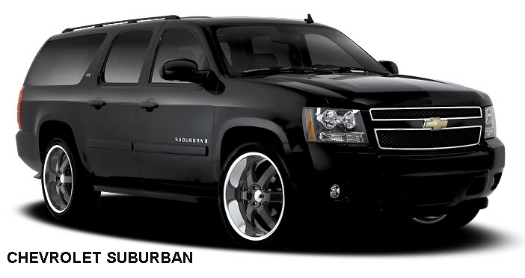 |  | 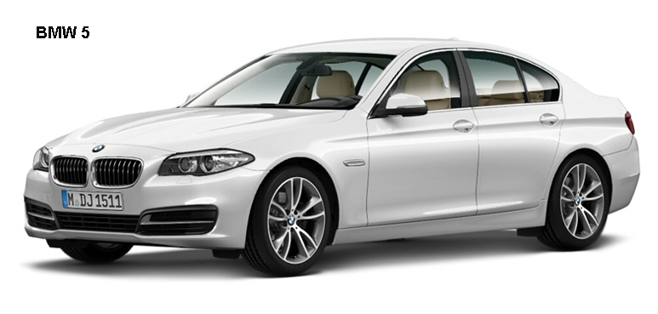
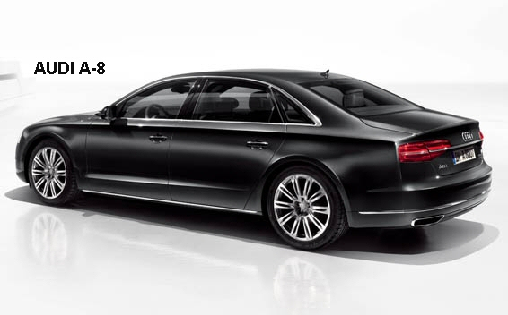 |  | 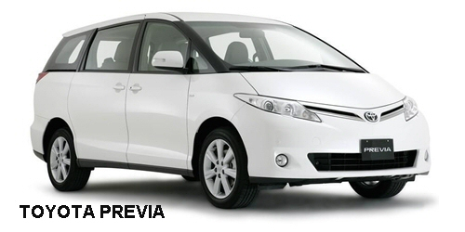
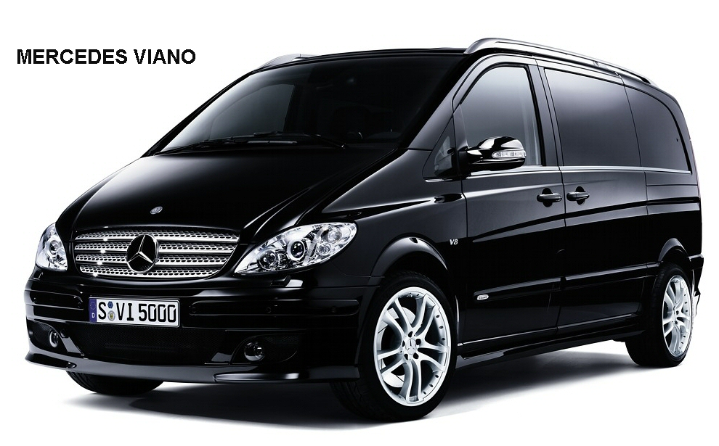 |  | 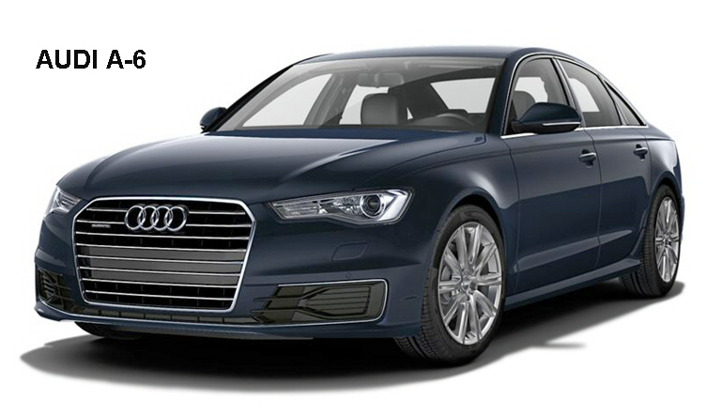
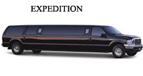 | 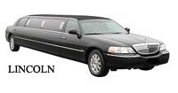 |  | 